**Introduction to Neural Networks**

Before that, let’s study a little mathematics (Linear Algebra)

Scalar (0D)

Vector (1D)

Matrix (2D) -> combination of vectors

Tensor -> collection of matrices

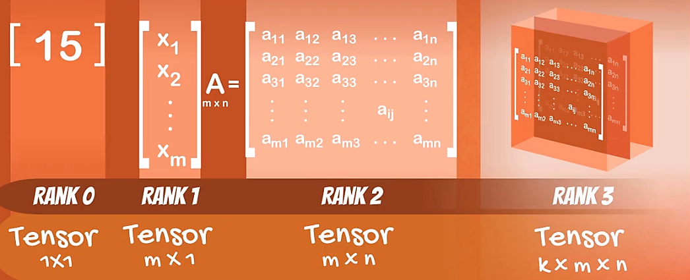

Transposing an array (vector, matrix or tensor) -> x.T in python

Dot product (scalar product) -> np.dot(x,y)

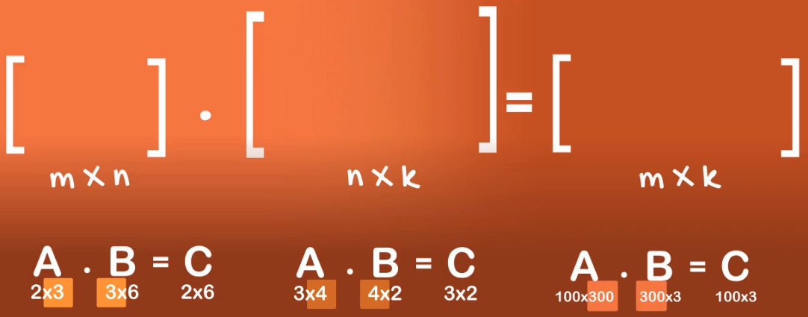

Ingredients of an Algorithm:

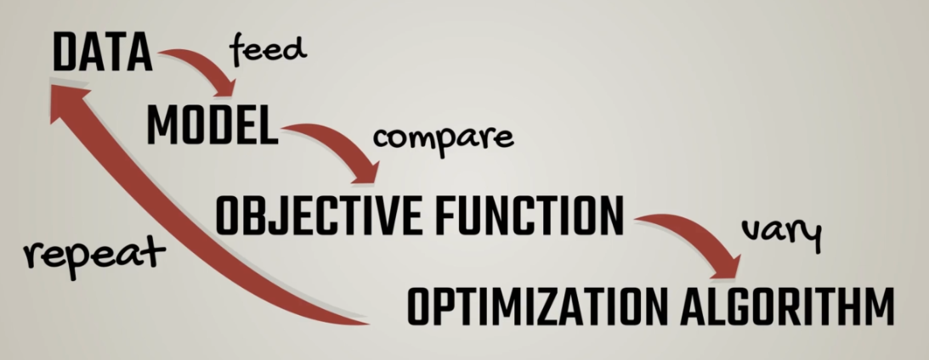

Training the model:

Coffee machine making coffee

Self-driving cars

**Types of Machine Learning:**

Supervised

Unsupervised

Reinforcement Learning

**What is a model?**

Example: Linear Regression

Y=xw+b

**Objective Function:**

Objective function is the measure used to evaluate how well the model’s outputs match the desired correct values.

It has two types:

* Loss Function (Example: Supervised Learning) aka cost function
  + For example: Regression cost function: L2 norm.
  + Classification: Cross entropy
* Reward Function (Example: Reinforcement Learning)

Optimization Algorithm: Example, Gradient Descent